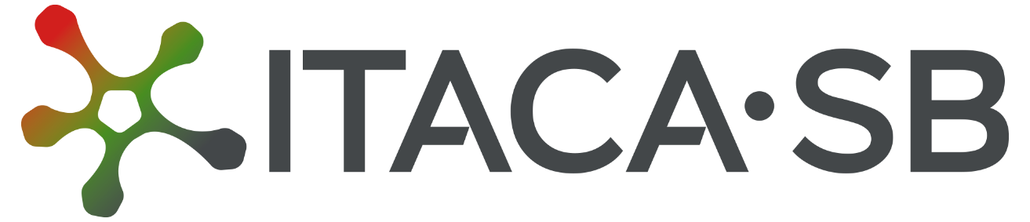

Potentiating the Italian Capacity for Structural Biology Services in Instruct-ERIC​






funded by the European Union’s NextGenerationEU under the MUR call 3264/2021 PNRR M4/C2/L3.1.1 (Project No. IR0000009, CUP B53C22001790006)

Annex III – Experiment Report Form

Transnational Access (TNA)
@ National Research Council

version 1.1 – September 8th, 2025
version 1.0 – February 15th, 2025
This form must be completed by the local contact responsible for the experiment conducted with the instruments provided by the ITACA.SB Research Infrastructure.

Once completed, the report should be saved in pdf format and emailed to the user(s) no later than 7 days after the conclusion of the experiment.

The report should then be signed by the user (or PI) and returned to the local contact.

Proposal Review Panels reserve the right to decline new proposals from users who fail to submit a signed report concerning previously allocated instrument time.

The report should describe the results and outcome of the experiment session. It must be written in English with a minimum font size of 12 and include any relevant tables or figures.

It is free-text and should cover at least the following:
- Description / number of samples / projects measured;
- Description of the measurements made.

The experiment report will remain confidential for 3 years from the end date of the experiment session (visible only to proposal reviewers, the user team and relevant ITACA.SB staff).

User information

First Name:

Last Name:

Affiliation:

Phone Number:

E-mail address:

Project ID:

Title of project:

Services requested

Service ID:

Service description:

Number of hours/days granted:

Date(s) (dd/mm/yyyy):

Final total cost (€):

Name of the local contact:

E-mail address of the local contact:
Report

Service delivery confirmation

I hereby confirm that the service has been duly delivered in accordance with the agreed terms.

Date, DD/MM/YYYY | User’s signature:

Please type the real final cost

